* From USDA, we have 2018 to 2022 crop price and yield for each county

* Bridge LandIQ crops with USDA Crops

* Remove from USDA:
  + crops that won’t be used for bridging
  + crops that don’t have data

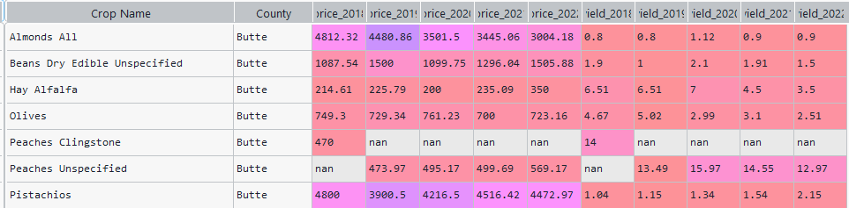

* In USDA, some crops have been renamed so we merge the ones that are the same.
  + Seed Rice
  + Plums Dried (prunes)
  + Peaches
    - Peaches Clingstone and Peach unspecified in butte county look the same
    - In other countys we have both clingstone and freestone

* Berries
  + Not sure what to do

* Hay
  + Do I combine them?



* Update the df for bridging datasets and save it on excel

Python Files:

1. download_usda_crops.py: this downloads crops data and saves it as a dictionary in pickle  
   A screenshot of a computer

   Description automatically generated
2. save_csv: convert dic to csv 2018 to 2022 prices and yield for each crop in each county

1. keep the relevant crops.py: in usda, here we keep the crops that we need (and those that have price and yield) and do it in conjunction with the id excel file where we bridge landiq and usda

Extra

1. plotting_usda_crop_prices.py: this plots price of each crop in each county. change in price from 2018 to 2022

Result

Here I’ve removed non irrigated lands (I, X, P1, P3, P4, P5, P6, P7).

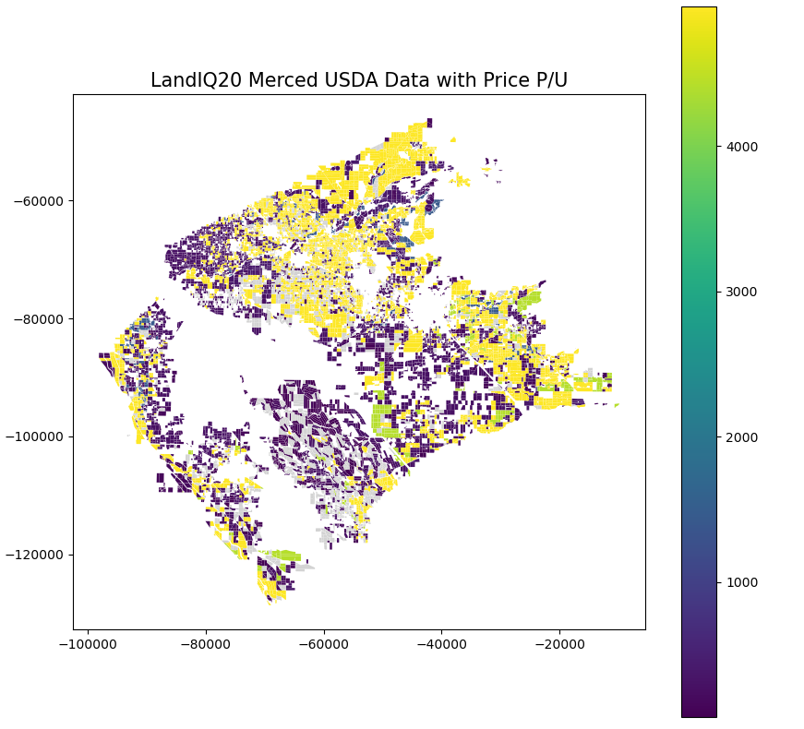

Future work:

We can replace some crops with others that exist in that region. For example, in Merced we don’t have Cotton lint Unspecified, but we do have:  


Similarly for Potatoes All, we can replace it with as follows:  


In some area we don’t have that crop that all, thus we need to replace it with the price of the crop in a nearby region.